UI Design Comparison Report
Title
Comparison of the User Interface Design of spotify and youtube music.
Submitted By
" Name: Kavyasri.V
" Register Number: 261CB010
" Class: BCA
" Subject: UI & UX
" Date: 17.08.2026
________________________________________
1. Aim
To compare the User Interface (UI) design of two mobile applications and identify their strengths, weaknesses, and usability based on visual design elements.
________________________________________
2. Applications Selected
Application 1: Spotify
Application 2: Youtube music
Reason for Selection: music is very important thing and it plays important role in everyones life.
________________________________________
3. Introduction
User Interface (UI) refers to the visual elements through which users interact with an application. A good UI should be attractive, simple, and easy to understand. This report compares the UI design of spotify and youtube music based on different design aspects.
________________________________________
4. Comparison of UI Elements
4.1 Home Screen
spotify has a clean and simple home screen with fewer options. Frequently used features are clearly displayed.
Youtube music provides many services on the home screen, making it feature-rich but slightly crowded.
Observation: spotify is easier for first-time users.
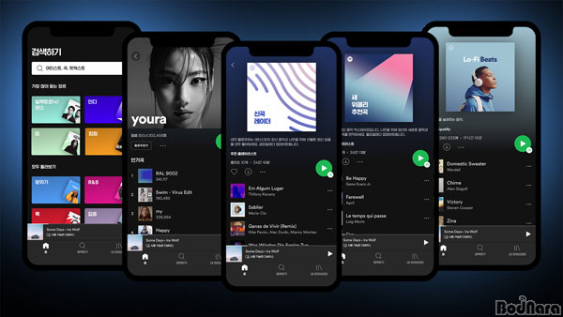
This Photo by Unknown Author is licensed under CC BY-NC-ND
________________________________________
4.2 Color Scheme
spotify mainly uses white and blue colors, creating a clean appearance.
Youtube music uses a purple theme with multiple colorful icons.
Observation: spotify looks minimal, while youtube music appears more vibrant.
________________________________________
4.3 Typography
Spotify uses readable font sizes with good spacing.
Youtube music also uses clear fonts, but the larger number of options makes the screen appear busier.
Observation: Both applications have readable fonts.
________________________________________
4.4 Icons
Spotify uses simple icons with labels.
Youtube music uses colorful icons representing various services.
Observation: Both applications use understandable icons.
________________________________________
4.5 Buttons
Spotify provides large action buttons for payments and scanning QR codes.
Youtube music also provides visible buttons but includes more shortcut options.
Observation: spotift’s buttons are easier to identify.
________________________________________
4.6 Navigation
Spotify has fewer menu options, making navigation simple.
Youtube music contains additional categories and services.
Observation: spotify requires fewer steps for common tasks.
________________________________________
4.7 Layout
Spotify maintains proper spacing between elements.
Youtube music displays more content on a single page.
Observation: spotify has a cleaner layout.
________________________________________
4.8 Accessibility
Both applications use readable text and large touch buttons.
spotify's simple design may be easier for elderly users.
________________________________________
5. Comparison Table
UI Feature spotify youtube music
Color Scheme Excellent Very Good
Typography Excellent Very Good
Icons Excellent Excellent
Buttons Excellent Good
Navigation Excellent Very Good
Layout Excellent Good
Accessibility Excellent Very Good
________________________________________
6. Strengths and Weaknesses
spotify
Strengths
" Clean interface
" Simple navigation
" Large buttons
" Easy to understand
Weaknesses
" Fewer shortcuts
" Limited personalization
________________________________________
Youtube music
Strengths
" Many useful services
" Attractive colors
" Rich feature set
Weaknesses
" Crowded home screen
" More options may confuse new users
________________________________________
7. Suggestions
spotify
" Add more customization options.
" Improve feature discoverability.
Youtube music
" Reduce clutter on the home screen.
" Group similar services together.
________________________________________
8. Conclusion
Both applications provide user-friendly interfaces. Spotify offers a cleaner and more minimal design, making it suitable for beginners. Youtube music provides a greater` number of services but has a busier interface. Based on this comparison, spotify offers a better overall UI for first-time users due to its simplicity and ease of navigation.

